People Stories: Design and Manufacturing

Sharon Standing, Manufacturing Manager
Sharon is one of Tunstall Healthcare’s longest serving employees, celebrating 40 years with the company this November. She shares her progress through the company, and her observations on how things have changed during this time.
I started at Tunstall as an assembly operator in November 1982 when I was 18. At this point the company was still based in Askern near Doncaster, before the purpose-built factory and offices were constructed at Whitley. I’d worked part time at a local café and cake factory, but this was my first full time job.
In those days, Tunstall was basically still a cottage industry, with around 30 employees working out of what I can only describe as metal huts, one for manufacturing, one for testing and one for stores. There was also a basic canteen but I still remember have to put my coat on and run across to get to it in all weathers!
We were all multi-skilled; everyone knew everyone else’s jobs and could cover for each other if they were sick or on holiday. That really helped, as we all appreciated the roles our colleagues played and were happy to help each other out, and to this day I still work with four colleagues that joined Tunstall around the same time. Mike Dawson was Managing Director.
A new home
After a few months of me starting, the new factory and head office at Whitley was ready. It was such a change! Everything was brand new, from the manufacturing equipment to the desks and the chairs. We’d seen photographs of it as it grew out of the footings, but it was still a real moment to be in this huge, modern, light, airy working environment for the first time.
The move to the new factory marked a massive turning point. Tunstall quickly grew to become a national market leader and global innovator. The investment in manufacturing equipment meant we needed to adapt manual processes to automated ones, retaining our high levels of quality but enabling us to deliver at scale. There was a huge shift in output, as well as the culture and mindset. I’ve seen our portfolio expand from group living (warden call) systems with pullcords to Lifeline home units and a whole range of sophisticated telecare sensors. We’ve moved from working with the housing department of local authorities to supply basic alarms to partnering with health, housing and social care to deliver integrated, preventative technology solutions.
Making progress
After around five years at Tunstall I became a manufacturing team leader, then known as a charge hand. After that I held various supervisory roles, and ten years ago I was made Production Manager. It actually wasn’t a role I ever thought I’d actively go for. I wanted to lead a team and be innovative and share my knowledge and skills, but I didn’t always have the confidence. Now I absolutely love it, and I’m so proud of what we achieve every day.

There is a huge expertise involved in what we do, and everyone recognises the importance of delivering this 100%. We invest in our people, training them in a wide range of skill sets, and varying their tasks throughout the course of working days to make their roles more fulfilling.
One of the reasons the colleagues at Tunstall are so dedicated is that most of us have or have had people in our lives that have used our services. All of us absolutely recognise that what we do can save lives and feel passionately about that. My mum for example has a Lifeline. She’s only needed to use it twice, but it means I understand the reassurance we give. What we do is about home and family and there’s not much more important than that to most people.
The covid challenge
The pandemic was especially challenging. The world changed overnight. We could see the company emptying around us, and we had members of the team that needed to shield. Throughout it all we managed to retain almost full production capacity. We made changes to accommodate social distancing, both on the shop floor and in terms of shift patterns. But none of that would have been enough without the dedication of the people that work here and care deeply about what we do. People came in early, worked longer shifts, covered for colleagues and generally wanted to be here because they know the difference we make. I am very proud of my team and how they all coped during the pandemic.
There are always challenges in any job, but for me the focus is on constantly striving to do things better. Technology doesn’t stand still, and everyone in the business is always looking for different approaches and new ways to improve what we do.
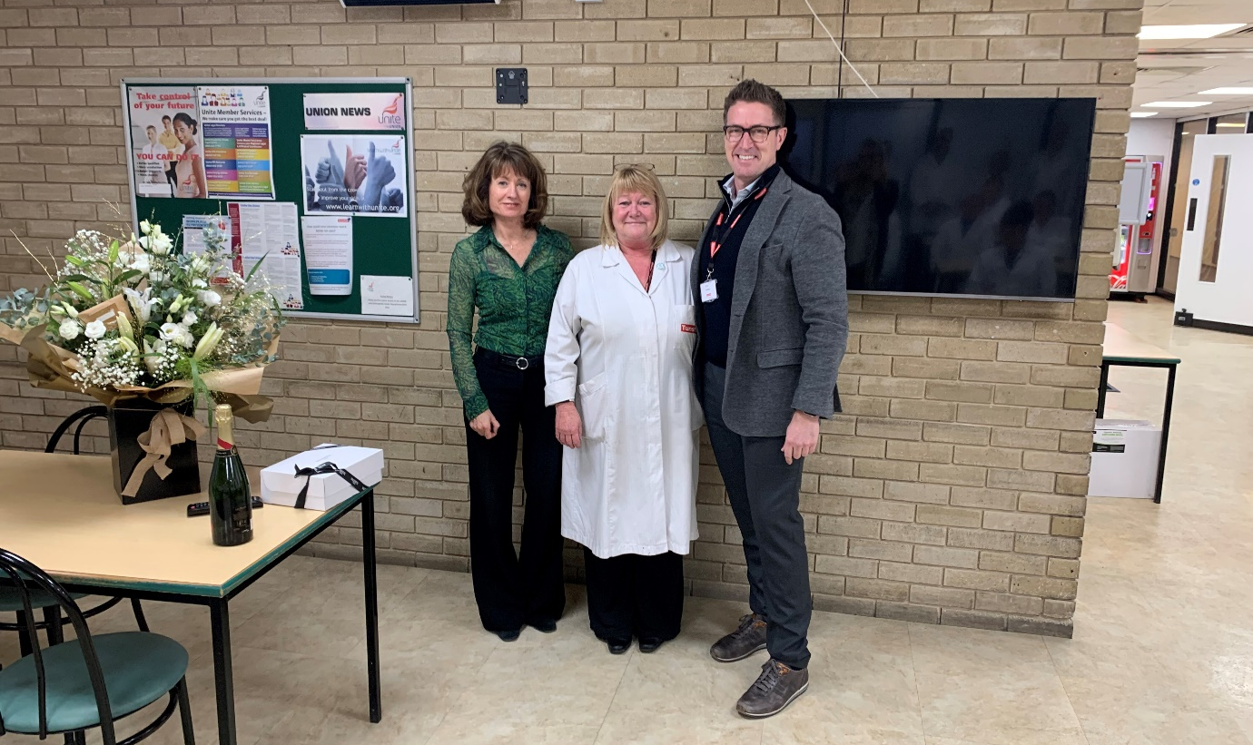
In terms of the future, we know software will play an increasing role in what Tunstall offers, but as social care and health remain under huge pressure, devices will also play a key part in how we deliver these essential services effectively and I am so proud to be part of manufacturing these in the UK.
From left to right: Elaine Quinn, Group Operations Director; Sharon Standing, Manufacturing Manager; Emil Peters, CEO

